Group Project 1 Julien Bankier

Find each query, the proposition and the results grouped by complexity
Problems 1 - 20 by complexity group

Table Of Contents

Simple Querries: 3
Problem 1 3
Problem 2 4
Problem 3 5
Problem 4 6
Problem 5 8
Medium Queries 10
Problem 6 10
Problem 7 11
Problem 8 12
Problem 9 13
Problem 10 15
Problem 11 17
Problem 12 19
Problem 13 20
Complex Queries: 21
Query 14: 21
Problem 15 22
Problem 16 23
Problem 17 24
Problem 18 25
Problem 19 27
Problem 20 28

Simple Querries:

Problem 1

Proposition: A business wants to know which products are discontinued and how much they were selling for.

Query:
SELECT o.Quantity
,p.ProductName
,p.SupplierID
FROM Sales.OrderDetail o
LEFT JOIN Production.Product p ON o.ProductId = p.ProductId
WHERE Discontinued = 1
ORDER BY o.Quantity DESC

Diagram:
Results:

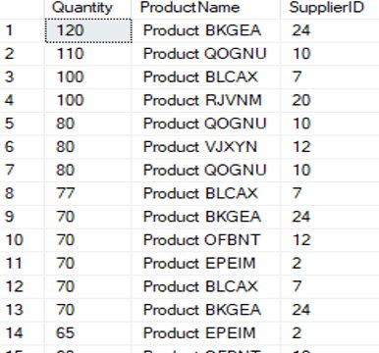

Problem 2
Proposition: A business wants to know which products are being supplied by which company

Query:
SELECT s.SupplierCompanyName
,p.ProductName
FROM Production.Supplier s
INNER JOIN Production.Product p ON s.SupplierId = p.SupplierId

Diagram:
Results:

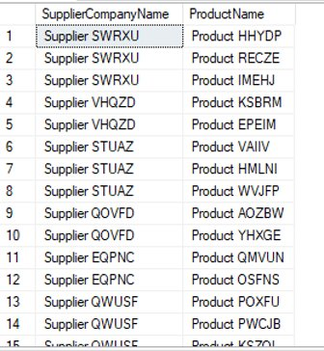

Problem 3
Proposition: A business wants to know the description of the category of each product

Query:
SELECT p.ProductName
,c.[Description] AS 'Description'
FROM Production.Product p
INNER JOIN Production.Category c ON p.CategoryId = c.CategoryId
ORDER BY 'Description'

Diagram:
Results:
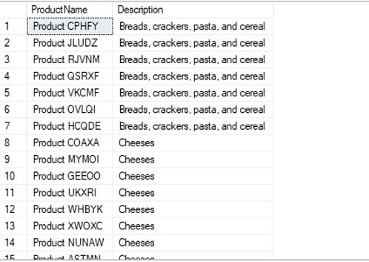

Problem 4
Proposition: A business wants to see which company is shipping product to France

Query:
SELECT o.ShipToCountry AS Country
,o.ShipToDate AS DateShipped
,s.ShipperCompanyName AS ShipperCompany
FROM Sales.[Order] o
LEFT JOIN Sales.Shipper s ON o.ShipperId = s.ShipperId
WHERE o.ShipToCountry = 'France'
ORDER BY ShipperCompany

Diagram:

Results:
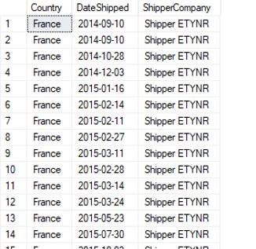

Problem 5
Proposition: A business wants to see what order was booked by which employee
Query:
SELECT o.orderID
,e.EmployeeLastName
,e.EmployeeFirstName
FROM Sales.[Order] o
LEFT JOIN HumanResources.Employee e ON o.EmployeeId = e.EmployeeId

Diagram:

Results:

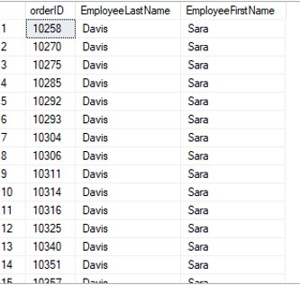

Medium Queries

Problem 6
Proposition: A business wants to see the total discounted being applied to their sales
Query:
SELECT o.OrderId
,MAX(o.OrderDate) AS orderDate
,SUM(od.Quantity) AS tQuantity
,SUM(od.DiscountPercentage) AS tDiscount
FROM Sales.[Order] o
INNER JOIN Sales.OrderDetail od ON o.OrderId = od.OrderId
GROUP BY o.OrderId
Diagram:

Results:
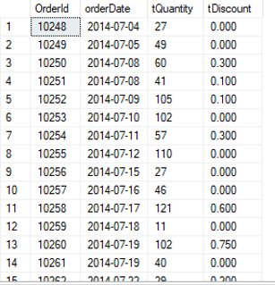

Problem 7
Proposition: A business wants to know the most units sold in a single order
Query:
SELECT o.OrderId AS OrderID
,SUM(od.Quantity) AS QuantitySold
,e.EmployeeLastName
,MAX(o.OrderDate) AS orderDate
FROM Sales.[Order] o
INNER JOIN Sales.OrderDetail od ON o.Orderid = od.Orderid
INNER JOIN HumanResources.Employee e ON o.EmployeeId = e.EmployeeId
GROUP BY e.EmployeeLastName
,o.OrderId
ORDER BY QuantitySold DESC

Diagram:
Results:
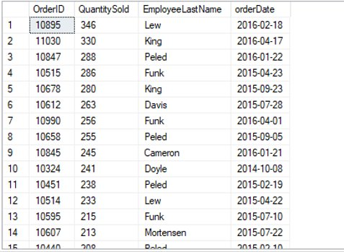

Problem 8
Proposition: A business wants to know the total freight going to each country
Query:
SELECT Sum(o.Freight) AS TotalFrieght
,sh.ShipperCompanyName
FROM Sales.[Order] o
INNER JOIN Sales.Shipper sh ON o.ShipperId = sh.ShipperId
GROUP BY sh.ShipperCompanyName
ORDER BY TotalFrieght DESC
Diagram:
Results:

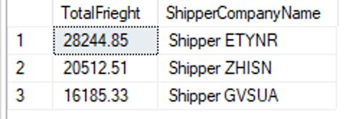

Problem 9
Proposition: A business wants to know what company is ordering the least amount of items
Query:
-- Customer companies with the least total orders Medium 4
SELECT c.CustomerCompanyName
,SUM(od.Quantity) AS TotalOrderQuantity --, o.OrderDate
FROM Sales.[Order] o
LEFT JOIN Sales.Customer c ON o.CustomerId = c.CustomerId
LEFT JOIN Sales.OrderDetail od ON o.OrderId = od.OrderId
GROUP BY c.CustomerCompanyName
ORDER BY TotalOrderQuantity
Diagram:

Results:

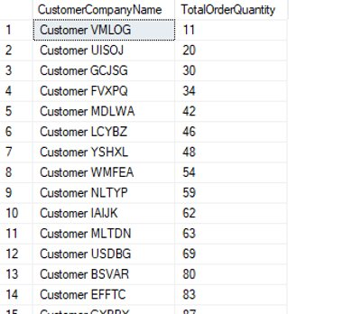

Problem 10
Proposition: A business wants to know what it's most popular products are per city
Query:
SELECT SUM(od.Quantity) AS 'Total Quanity'
,o.ShipToCity AS City
,p.productID AS ProductID
,c.[Description] AS 'Product Type'
FROM Sales.OrderDetail od
INNER JOIN Production.Product p ON od.ProductId = p.ProductId
INNER JOIN Sales.[Order] o ON od.OrderId = o.OrderId
LEFT JOIN Production.Category c ON p.CategoryId = c.CategoryId
WHERE Discontinued = 0
GROUP BY o.ShipToCity
,c.[Description]
,p.ProductId
ORDER BY 'Total Quanity' DESC
Diagram:

Results:
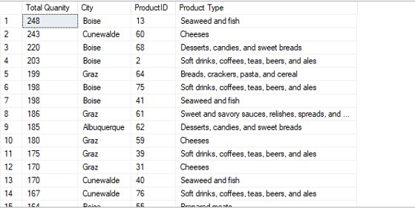

Problem 11
Proposition: A business want's to see what products are discontinued per category
Query:
SELECT c.CategoryName
,COUNT(*) AS DiscontinuedUnitCount
FROM Sales.OrderDetail s
LEFT JOIN Production.Product p ON s.ProductId = p.ProductId
LEFT JOIN Production.Category c ON p.CategoryId = c.CategoryId
WHERE Discontinued = 1
GROUP BY c.CategoryName
Diagram:

Results:

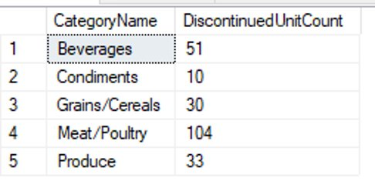

Problem 12
Proposition: A business wants to know what employee is selling the most to what country
Query:
SELECT o.ShipToCountry AS Country
,SUM(od.Quantity) AS Quantity
,e.EmployeeLastName AS LastName
FROM Sales.[Order] o
LEFT JOIN Sales.OrderDetail od ON o.OrderId = od.OrderId
INNER JOIN HumanResources.Employee e ON o.EmployeeId = e.EmployeeID
GROUP BY o.ShipToCountry
,e.EmployeeLastName
ORDER BY Quantity DESC

Diagram:
Results:

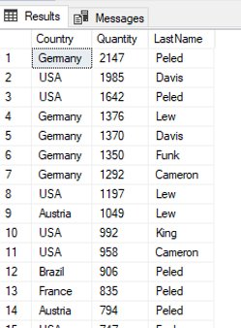

Problem 13
Proposition: A business wants to know the amount of orders per day
Query:
SELECT o.OrderDate
,COUNT(od.OrderId) AS unitsSoldPerOrder
FROM Sales.[Order] o
LEFT JOIN Sales.OrderDetail od ON o.OrderId = od.OrderId
GROUP BY o.OrderDate
ORDER BY o.OrderDate
Diagram:

Results:
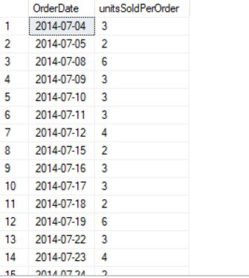

Complex Queries:

Query 14:
Proposition: A business wants to know net sales of an employee after the discount percentage
Query:
SELECT SUM(Sales.udfSalesAfterDiscount(od.Quantity, od.UnitPrice, od.DiscountPercentage)) AS TotalSalesAfterDiscount
,SUM(Sales.udfSalesAfterDiscount(od.Quantity, od.UnitPrice, 0)) AS TotalSalesWithoutDiscount
,e.EmployeeLastName
,e.EmployeeID
FROM Sales.[Order] o
LEFT JOIN Sales.OrderDetail od ON o.OrderId = od.OrderId
LEFT JOIN HumanResources.Employee e ON o.EmployeeID = e.EmployeeID
GROUP BY e.EmployeeID
,e.EmployeeLastName
ORDER BY TotalSalesAfterDiscount DESC
Diagram:
Results:
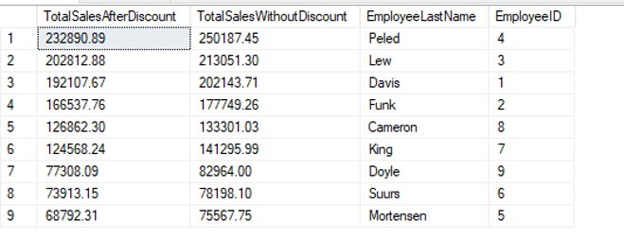

Problem 15
Proposition: A business wants to know its total cost, margins per sale per unit, and total profit
Query:
SELECT p.UnitPrice AS UnitCost
,od.UnitPrice AS UnitSales
,od.UnitPrice - p.UnitPrice AS MarginPerUnit
,od.Quantity
,Sales.udfSalesAfterDiscount(p.UnitPrice, od.Quantity, 0) AS TotalCost
,Sales.udfSalesAfterDiscount(od.UnitPrice, od.Quantity, SUM(od.DiscountPercentage)) AS TotalSales
,od.ProductID
,s.SupplierCompanyName AS SupplierCompanyName
,Sales.udfSalesAfterDiscount(od.UnitPrice, od.Quantity, SUM(od.DiscountPercentage)) - Sales.udfSalesAfterDiscount(p.UnitPrice, od.Quantity, 0) AS TotalRevenue
FROM Production.Product p
LEFT JOIN Sales.OrderDetail od ON p.ProductID = od.productID
LEFT JOIN Production.Supplier s ON p.SupplierId = s.SupplierId
GROUP BY od.ProductID
,p.unitPrice
,od.unitPrice
,od.Quantity
,s.SupplierCompanyName
Diagram:

Results:

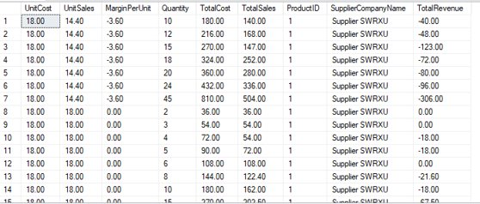

Problem 16
Proposition: A business wants to know which shipping company represents what percentage of it's shipment
Query:
SELECT SUM(o.Freight) AS TotalFreight
,Sales.udfPercent(Sum(o.Freight), 64942.69) AS percentageOfFreight
,sh.ShipperCompanyName
FROM Sales.[Order] o
INNER JOIN Sales.Shipper sh ON o.ShipperID = sh.ShipperID
GROUP BY sh.ShipperCompanyName
Diagram:

Results:

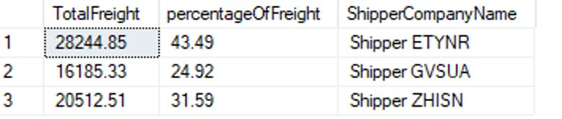

Problem 17
Proposition: A business wants to know net sales of all employees after discounts
Query:
SELECT SUM(Sales.udfSalesAfterDiscount(od.UnitPrice, od.Quantity, od.DiscountPercentage)) AS Sales
,e.EmployeeLastName
,e.EmployeeId
FROM Sales.[Order] o
INNER JOIN Sales.OrderDetail od ON o.OrderId = od.Orderid
INNER JOIN HumanResources.Employee e ON o.EmployeeID = e.EmployeeID
GROUP BY e.EmployeeLastName
,e.EmployeeId
ORDER BY Sales DESC

Diagram:

Results:
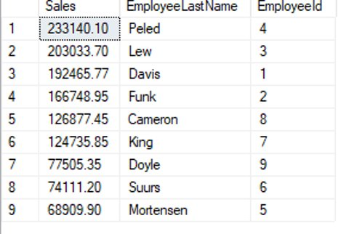

Problem 18
Proposition: A business is interested in its top sales in France, and the details about those sales
Query:
SELECT od.Quantity
,od.UnitPrice
,SUM(Sales.udfSalesAfterDiscount(od.Quantity, od.UnitPrice, od.DiscountPercentage)) AS 'Total Sales'
,o.OrderId
,o.OrderDate
,o.ShipToCountry
,c.[Description]
FROM Sales.[Order] o
INNER JOIN Sales.OrderDetail od ON o.OrderId = od.OrderId
INNER JOIN Production.Product p ON od.ProductId = p.ProductId
INNER JOIN Production.Category c ON p.CategoryId = c.CategoryId
WHERE o.ShipToCountry = 'France'
GROUP BY o.ShipToCountry
,od.Quantity
,od.UnitPrice
,c.[Description]
,o.OrderId
,o.OrderDate
ORDER BY 'Total Sales' DESC
Diagram:
Results:

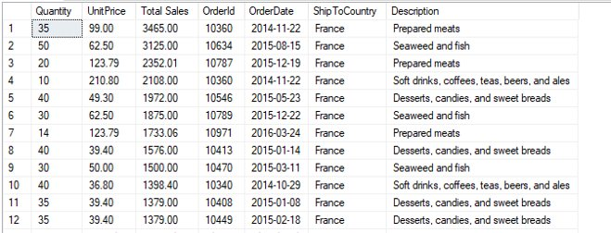

Problem 19
Proposition: A business wants to know who it's best and worst customers are and their contact information
Query:
SELECT SUM(Sales.udfSalesAfterDiscount(od.Quantity, od.UnitPrice, od.DiscountPercentage)) AS 'Total Sales'
,c.CustomerCompanyName AS 'Company Name'
,c.CustomerContactName AS 'Contact Name'
,c.CustomerPhoneNumber AS 'Contact Number'
,c.CustomerCountry
FROM Sales.[Order] o
INNER JOIN Sales.OrderDetail od ON o.OrderId = od.OrderId
INNER JOIN Production.Product p ON od.ProductId = p.ProductId
INNER JOIN Sales.Customer c ON o.CustomerID = c.CustomerID
WHERE p.Discontinued = 0
GROUP BY c.CustomerCompanyName
,c.CustomerContactName
,c.CustomerPhoneNumber
,c.CustomerCountry
ORDER BY 'Total Sales' DESC

Diagram:

Results:

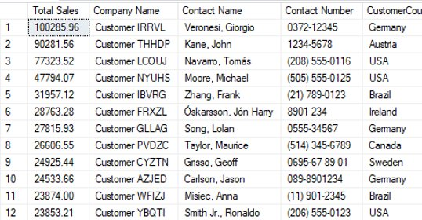

Problem 20
Proposition: A business wants to know everything about it's sales on a particular product
Query:
SELECT p.ProductName
,s.SupplierCompanyName
,Sales.udfPercent(Sum(od.Quantity), 366) AS 'Percent of Total Cheese Sold'
,SUM(Sales.udfSalesAfterDiscount(od.Quantity, od.UnitPrice, od.DiscountPercentage)) AS 'Total Cheese Sales'
,cu.CustomerCompanyName
,cu.CustomerContactName
,cu.CustomerPhoneNumber
,cu.CustomerCountry
FROM Sales.[Order] o
INNER JOIN Sales.OrderDetail od ON o.OrderId = od.OrderId
INNER JOIN Production.Product p ON od.ProductId = p.ProductId
INNER JOIN Production.Category c ON p.CategoryId = c.CategoryId
INNER JOIN Production.Supplier s ON p.SupplierId = s.SupplierId
INNER JOIN Sales.Customer cu ON o.CustomerId = cu.CustomerId
WHERE p.Discontinued = 0
AND c.[Description] = 'Cheeses'
GROUP BY s.SupplierCompanyName
,p.ProductName
,cu.CustomerCompanyName
,cu.CustomerContactName
,cu.CustomerPhoneNumber
,cu.CustomerCountry
ORDER BY 'Percent of Total Cheese Sold' DESC

Diagram:

Results:

